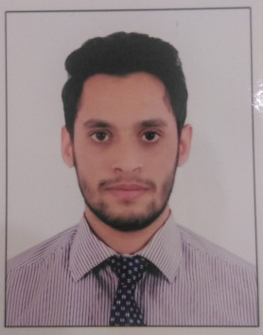
Aftab Hamid

Doha, Qatar
aftabhameed3@gmail.com
+974 33160800

Professional Profile
Mechanical Site Engineer with 2 years of GCC Experience seeking a position where I can contribute my skills and experience to the further development of the organization and achieve growth in my professional career.

Relevant Work Experience
Dec 2015- July 2017  Sep 2015 - Dec 2015 |  | MEP Site Engineer  Doha Oasis Mixed Use Development  - Planning work and efficiently organize the site facilities in order to meet the schedules.  - Responsible for day-to-day installation of Mechanical Equipments like HVAC system, Pipe Works and pumps and valves.  - Ensure the Health and Safety is first and foremost in all work activities.  - Lead a team of Site operatives and providing technical support and ensuring high standards of installation and workmanship.  - Review Material Submittals and construction schedules to ensure construction quality and sustainability.  - Monitor service performance and ensure a proactive work structure and that installation work is completed within agreed programmed limits.  - Ensure compliance with design and agreed materials.  - Ensure that correct procedures are undertaken during testing and commissioning stages.  - Management and supervision of specialist subcontractors  - Accountable for Labor numbers and attendance.  - Ensure site documents is kept up to date.  Mechanical Site Engineer  CICB - Chemicon  - Daily site visiting and close monitoring the construction activities on site  - Checked pipe support as per isometric drawings.  - Erection, fabrication and commissioning of boilers, storage tanks, piping and valves.  - Prepare reports for day to day results.

Education
2015 |  | Bachelor of Engineering  Visvesvaraya Technology University - Mangalore, India  Major: Mechanical Engineering
2010 |  | HighSchool  Ideal Indian School -Doha Qatar

Skills
- ASNT LEVEL 2 Certification in Non-Destructive Testing
- Certification in Welding Inspection basic
- Certification in Quality control(Piping Inspection)
- Valuable experience in Solid Edge and Auto-CAD
- Well verse with MS-Office, ANSYS and Other computer skills

Personal Information
Date of Birth |  | 18 August 1992
Passport No.  Visa Status |  | N0757108  Valid residence visa under father's sponsorship, QID no#29235601435  (Expiry: 09/04/2018)
Driving License Indian(Valid), Qatar(Valid)
Languages known English, Hindi, Kannada
Nationality Indian
Gender Male
Availability Immediately

