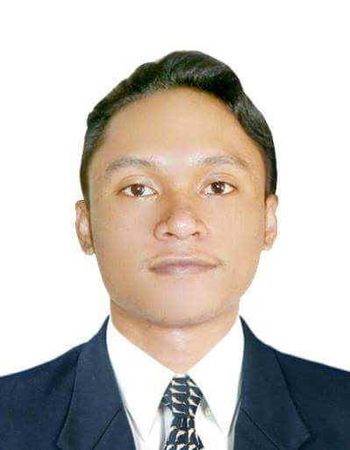

JOSHUA L FLORMATA

PRC No. 2318972 September 2016
465 Bolosan District
Dagupan City, Pangasinan
Mobile No: 50842917

Email: flormatajoshua@gmail.com

CAREER OBJECTIVES

To develop my strength of character out of struggle by doing not only the best but also exerting the talents and abilities for the production of the company and towards the realization of my goal in life.

WORK EXPERIENCE

Production Engineer/Mechanical Equipment Design Engineer
ROHM Electronics Philippines Inc.
People’s Technology Complex, Carmona Cavite
January 11, 2017 – December 2018

- Responsible for conceptualizing, 3D design, 2D detailing, testing and final set up of machine improvements that are used to produce large scale integrated circuits such as die bond, wire bond, molding and testing machines
- Responsible for prototyping, evaluation, documentation and mass production of newly developed machine parts
- Responsible for sourcing, testing and selection of supplies, and for providing fabricators with specific treatment and other machining procedures
- Responsible for troubleshooting and investigation of machine breakdown, providing countermeasures for chronic defects that are running in production line, and introducing efficient production line methods

Pipeline Designer
FC Laranang Group of Companies
Baguio,Benguet Philippines
June 2015 – July 2016

-Responsible for the overall plant layout, the plot plan, the equipment location, the pipe routing, the development of the CAD models, the piping isometrics.

Maintenance Engineer (On-the Job Training)
Toyota-La Union
Bauang La Union
March 15 2015- April 30 2015

EDUCATION

Bachelor of Science in Mechanical Engineering
Saint Louis University – Bonifacio rd. Baguio City
School of Engineering and Architecture
Baguio City
2010 –2016

TRAININGS , SEMINARS and RECOGNITION

- “ROHM PRODUCTION SYSTEM: INTER-DIVISION”
1ST Placer together with EDS Department
Total customer satisfaction thru elimination of 7 MUDA
August 15, 2018

- “ROHM PRODUCTION SYSTEM: DIVISION LEVEL”
1ST Placer MEE Department
Total customer satisfaction thru elimination of 7 MUDA
August 9, 2018

- “Small Group Activity: DIVISION LEVEL”
2nd Placer MEE Department
Provision of Buy-off for Special Parts
January 26-27, 2018

- “DESIGN AND MANUFACTURING WORKSHOP ”
Hands on Workshop CAD + CAM + CAE
Paseo Premiere Hotel, Laguna
June 20, 2018

- “CCS LIGHTING WORKSHOP ”
LED Lighting for Vision Application
Rohm Electronics Phil. Inc.
July 19, 2017

SKILLS

- Machine Design and Improvement
- Familiar with JIS technical drawing standards
- AutoCad (Technical Drawing, 2D, 3D)
- Microsoft Office (Word, Excel, PowerPoint)
- Knowledge in fabrication and machine handling

PERSONAL INFORMATION

- Birth Date: November 14 , 1992
- Birth Place: Dagupan City
- Civil Status: Single
- Citizenship: Filipino
- Height: 5’6”
- Father: Dante V Flormata
- Mother: Pastora L Flormata

CHARACTER REFERENCES

James Patrick Jetter
HSE Officer
30602305
Boom Construction

Narlo Balolot
Sr. Project Engineer
30886778
Boom Construction

Richard Lalicon
Project Manager
50276560
Arabtec Construction

I hereby certify that the facts contained in this resume are true and completed to the best of my knowledge.

_________________________
JOSHUA L FLORMATA
Applicant

