Abdul Jalal Penna Khaja
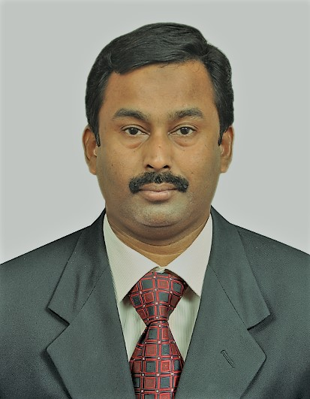
On Qatar visit: Mob: 7743 1860
jalal148@gmail.com https://www.linkedin.com/in/abduljalalpennakhaja
Executive Assistant / Office Manager
Decisive and results-oriented professional offering a career history of successful experience in executive administration, and supporting top management.
Highlights of Expertise
- Cross-Functional Team Coordination  - Correspondence/Communications  - Expense Reporting  - Meeting Coordination/Minute taking | - Scheduling & Diary Management  - Files & Records Management  - Team Building & Leadership  - Calendar/Travel Management

Career Experience
Alpine Coils, Chennai, India
Admin. Executive (09/2018 to till date)

- Partner with HR to maintain office policies as necessary
- Coordinate with IT department on all office equipment
- Provide general support to visitors
- Responsible for creating PowerPoint slides and making presentations
- Manage executives’ schedules, calendars and appointments
STC Channels (STC Group), Riyadh, KSA
Provided executive level support and managed all daily office operations, communications, and handled all logistics and materials for Board and Committee meetings.
EXECUTIVE ASSISTANT TO VICE PRESIDENT, HUMAN RESOURCES (01/2016 to 01/2018)
Administered support by management of multidimensional complex calendars and events, arranged all domestic and international travel/accommodations’ and developed critical documents utilizing multiple software programs.
- Effectively managed multiple functions in regard to incoming/outgoing mail, faxes, and coordinated all emails for appropriate disbursement and follow through.
- Developed processes and procedures to develop effective detailed expense reports, requests for capital expenditures and prepared for distribution.
- Utilized communications skills to author effective correspondence for diverse areas of the organization which included the creation of month to date reports.
- Introduced effective initiatives that drove workflow optimization, and increased accuracy and proficiency.

MAADEN – Saudi Arabian Mining Company, Riyadh, KSA
Provided general administrative duties, and drove communications efforts as well as inter-office memos and circulars, with responsibility to support the executive on meetings; planned and managed diary.
EXECUTIVE ASSISTANT TO SENIOR VP, HR & SUSTAINABILITY (06/2006 to 01/2016)
Assisted in all travel arrangements, which included pricing, logistics on hotel bookings, flight arrangements, and ground transportation. Supported deadline-driven operations, resolved issues, and coordinated all daily schedules.
- Operated multi-line phone system, conducted faxing, copying, printing, scanning, and oversaw inventory, and supply ordering.
- Planned, organized, and supported an ever-changing, high-dynamic work environment which included management of embassy visa applications and multiple important documents; created, filed, and tracked through process.
- Managed paper and electronic filing systems, and ensured strict confidentiality of information and correspondences.
DAMAC Group, Dubai, UAE
Oversaw Personnel, scheduled appointments, and organized detailed records in assisting the human resources department and facilitated as the Executive Secretary to the General Manager.
HR ASSISTANT & EXECUTIVE SECRETARY (04/1997 to 05/2006)
Assisted the department in employee programs and procedures, engaged in recruitment, and coordinated all processes related to employment. Established various Human Resource initiatives that improved employee morale and performance, and conducted orientations to foster positive attitudes and promote positive experiences for new employees.
- Coordinated wages, benefits, sick time, vacation time, and ensured documentation was aligned with contracts. Managed files and preparation of reports on hours worked, benefits, and exit interviews.
- Successfully coordinated recruiting efforts with a specific focus, developed all candidate correspondence, facilitated new hire orientation, and organized new hire documentations to ensure organization maintained a solid workforce.
- Booked travel arrangements and authored all offer letters and agreements to candidates who verbally accepted.
- Drove all aspects of the business including development, procurement of supplies, maintained ever-changing calendars, and applied lean processes to travel arrangements without compromising quality.

Education & Credentials

Bachelor of Science, Physics | University of Madras
Diploma in Secretarial Practices, TN Tech. Education (Stenography & Typing)
Technology Proficiencies - Microsoft Office – Word, Excel, PowerPoint, Outlook
Personal Information - Nationality: Indian
-----

