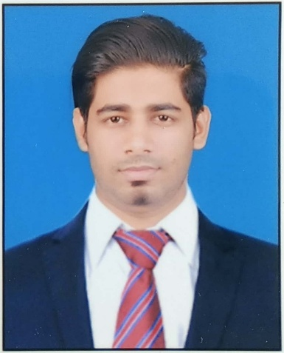
SAIF MOHAMMED MUNAF SOLKAR
MECHANICAL (QA QC) ENGINEER
EMAIL: saif.solkar2@gmail.com
CONTACT: +974 6642 0358 / +91 8149 458 108
ADDRESS: Near Retail Mart, Al Waqrah, Qatar

OBJECTIVES:
To secure a challenging position in a reputed organization where I can utilize my skills and gain further experience while enhancing productivity of the reputed organization.

ACADEMIC QUALIFICATIONS:
- Bachelor of Engineering (B.E.) in Mechanical Engineering
College: Rajendra Mane College of Engineering & Technology, Ratnagiri
University: Mumbai University
- Passed HSC examination with 71.83% from Mumbai Board
- Passed SSC examination with 83.38% from Mumbai Board
- Ongoing CSWIP 3.1 Welding Inspector
- Level II NDT in RT, PAUT, DPT & MPI from Aqsa NDT Services & Kaizen NDT Services
- Passed AutoCAD 2D from CAD Max, Ratnagiri

PROFESSIONAL EXPERIENCE:
- Working experience of 1 Year as a Quality Analysis & Quality Control Engineer at Ideal Offshore & Interior Works, Mumbai
- Working experience of 1 Year as a Quality Analysis & Quality Control Engineer in an ONGC & BG Project at Mathew Associates Hook Up & Weld Services, Navi Mumbai
- Working experience of 1 Year as a Quality Analysis & Quality Control Engineer at ASIAD Engineering & Welding Works, Raigad
- Total Experience: 3 Years in Oil & Gas Companies

STRENGTHS:
- Interpreting RT Films, reading PWHT & PAUT graphs
- Sufficient knowledge about the acceptance criteria regarding RT Films
- Sufficient knowledge regarding ASTM, ASME & other codes
- Good inspector of fit ups & welds
- Sufficient knowledge regarding electrodes & baking
- Reading isometric drawings of piping & structural drawings
- Capable of handling TPI & clients very well
- Capable of preparing WPS, LHS, PWHT & other kinds of reports
- Good knowledge of Microsoft Office Work
- English: speaking level – fluent, writing level – fluent, comprehension level – fluent

PERSONAL INFORMATION:
- Name: Saif Mohammed Munaf Solkar
- Gender: Male
- Date of Birth: 29 Oct. 1992
- Nationality: Indian
- Languages Known: English, Hindi
- Father's Name: Munaf Mohammed Solkar
- Mother's Name: Zareen Munaf Solkar
- Religion: Muslim (Category - OBC)
- Permanent Address: A/p Karla, House No. 178, Azad Area, Ratnagiri - 41562, Maharashtra, India
- Passport no.: R1191162 (Issued on. 21/06/17)

DECLARATION:
I hereby declare that the above cited information is true to the best of my knowledge and belief, if given a chance, I can prove myself.

Date:
Place: Saif M. Solkar

