SAREESH.P.S
Mobile no: +974-70541702
E-mail id: SAREESH1225@GMAIL.COM

Dear Sir/Madam,

If your organisation is looking forward for a skilled and experienced Electrical Draughtsman, I would welcome this opportunity to discuss potential contributions to your esteemed organisation. The accomplishment noted within the accompanying resume will illustrate the value and vision that can be added to your team.

Presently I’m working as an Electrical Draughtsman in VectorElectromechanical Doha.My expertise include strong hands on preparing shop drawing and installation details

In review of your company’s objectives and possible openings, I believe that my experience is in perfect line with your current needs. If your firm is looking for a dependable, result oriented professional with a solid performance track, I would be interested in speaking with you to discuss the value that my strengths and experience can bring your search. I can be reached in confidence at the above telephone number and look forward to hear from you.

Sincerely,
SAREESH
Enclosure:

- Resume

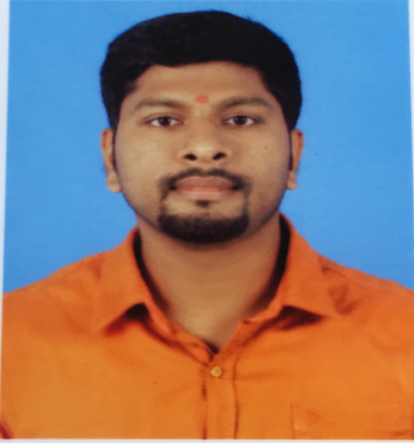

SAREESH.P.S
Mobile no: +974-70541702
E-mail id: SAREESH1225@GMAIL.COM

Electrical Draftsman
GENERALBACKGROUND

6-years’ experience as an Electrical Draftsman having Experience in Residential, Commercial, and Industries Buildings. Effective in working under pressure either independently or as a part of a team.

EDUCATIONAL QUALIFICATIONS
- 3 Years Diploma with 80.5% in Civil Engineering From
Kerala Technical Institute Thrissur- Kerala - India
- Passed High School Certificate (S.S.L.C) Examination with 80% marks.

- Passed High secondary School Certificate (+2) Examination with 75%.
COMPUTER QUALIFICATIONS
Graphic Software : AutoCAD 2007 TO 2016
Office Software : Ms Word, Ms Excel & Ms Power Point
VECTOR ELECTRO MECHANICAL:

Company : VECTOR ELECTRO MECHANICAL (GROUP OG SHARAKA
Position : Electrical Draughtsman
Period : 2016 Oct to 2018 feb

PROJECTS:
LE MIRAGE
2B+G+7+TECH+P RESIDENTIAL DEVOLOPMENT (5 BLDGS)
PLOT NO, 23510001 BIN MAHMOUD, DOHA QATAR

Main contractor : REDCO CONSTUCTION- ALMANA

Consultant : LACASA QATAR

Job position : Electrical Draughtsman

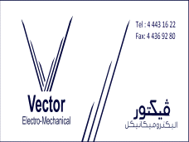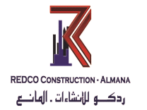
M
(5 BL

HARINSA QATAR:

Company : HA RIN SA QATAR (ECISA)
Position : Electrical Draughtsman
Period : 2014 Sep to 2016 June
PROJECTS:
WALDROF ASTORIA
3B+G+M+43 HOTEL & serviced apartment bldg.
On plot no. 61070167/68
AL QASSAR / AL DAFNA, DOHA, QATAR

Main contractor : HARINSA QATAR ( ECISA )

Consultant : LACASA QATAR

Job position : Electrical Draughtsman

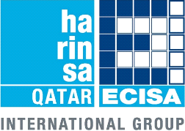
DRAKE &SCULL – MALL OF QATAR NEW LIFE STYLE SHOPPING DOHA QATAR 2013 feb to2014 aug

Main contractor : KCT – AL KHAYYAT CONTRACTING & TRADING
Consultant : KEO
Job position : Electrical Draughtsman

CAUVERY BUILTEC Ernakulum - Kerala – India(2012-2013)

Company : CAUVERY BUILTEC Ernakulum - Kerala - India
Position : Electrical Draughtsman
: Site Supervisor
Period : 2012 to 2013

JOB RESPONSIBILITIES:

- Preparation of Electrical shop drawings as per designed drawings for approval. Prior to implementation to site, such as:
- Lighting Layout
- Power Layout
- Fire Alarm System Layout
- BMS System Layout
- CCTV System Layout
- Telecommunication System Layout
- Preparation of Electrical Installation Details
- Preparation of As built drawings
- Co-ordinate to other service shop drawings (Mechanical, Structural & Architectural) and gathered some Information’s necessary in preparation of shop drawings.
- Preparing all necessary extracted – drawings/details attached on work inspection request (WIR)

PERSONAL DETAILS:

Name :SAREESH.P.S
Date of Birth : 08.09.1989

Father's Name : Sadasivan.P.K

Nationality : Indian

Marital Status : Single

Languages Known : Malayalam, English, Hindi and Tamil
Passport No : G 8691507
Visa status : TRANSFERABLE VISA
Date :
Place : ( SAREESH.P.S )

