Experience
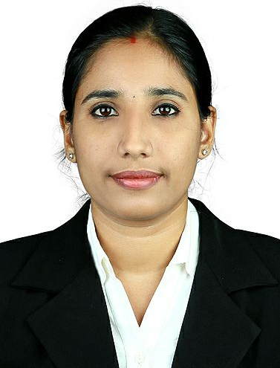

PRAJITHA CHANDRAN.V
  - REGISTERED NURSE

Objective
Looking for registered nurse position in a hospital to utilize efficient, professional, age specific, and exceptional nursing skills incurring out standard nursing procedure of assessment, planning implementation, and revision of the nursing care for a group of patients, following legal hospital polices.

Education
Post Basic Bachelor Of Nursing at Vivekanandha college of Nursing. Tiruchengode – 2011 Oct to 2013 Sep.
Mode of study- Active Enrollment
Diploma In General Nursing And Midwifery at Thrisur Metropolitan Health Care – 2007 Oct to 2011 Apr.
Mode of study- Active Enrollment
Plus Two -Science at St.Josephs Model School Kuriachira ,Thrissur, Kerala.
Completion -2007
S.S.L.C (10TH GRADE) at St.Raphels Convent Girls High School Ollur, Thrissur -Kerala
Completion -2005

ELITE MISSION HOSPITAL WITH 350 BEDS
NABH ACCREDITED
Staff Nurse: ICU Department
Duration: 18/07/2018 to 18/04/2019
Location: Thrissur, Kerala

RESPONSIBILITY

- Careful assessment and monitoring of patient progress
- Watch for sudden or subtle changes in a patient's medical condition
- Managing medical equipment’s, monitors and ventilator
- Update patient laboratory values
- Taking regular blood tests
- Changing the patient’s treatment in line with test results
- Giving the patient the drugs and fluids that the doctors have prescribed
- Recording the patient’s blood pressure, heart rate and oxygen levels
- Clearing fluid and mucus from the patient’s chest using a suction tube
- Turning the patient in his or her bed every few hours to prevent sores on the skin
- Cleaning the patient’s teeth and moistening the mouth with a wet sponge
- Washing the patient in bed
- Changing the sheets
- Changing a patient’s surgical stockings, which help circulation when he or she is inactive (lying still) for a long time

KALLIYATH HOSPITAL MULTISPECILATY HOSPITAL WITH 150 BEDS
Staff Nurse: ICU Department
Duration: 16/04/2017 to 16/07/2018
Location: Malappuram, Kerala

RESPONSIBILITY

- Identify Patients Age needs and after care plans as necessary to must those needs.
- Perform approved therapeutic or diagnostic procedure based upon patients clinal status.
- Evaluate patient’s vital signs and laboratory data to determine emergencyintervention needs.

- Administer blood and blood products, monitoring patients for signs and symptoms related to transfusion reactions.
- Administer medications intravenously, by injection, orally, through gastric tubes or by other methods,
- Advocate for patients and family’s needs or provide emotional support for patients and their families.

SKILLS
Multitasking, Prioritizing, Communication, Kindness, Observation, Physical Endurance.

tECHANICAL SKILLS
Computer operating, Microsoft Excel, Handling Equipment’s.

- Setup and monitor medical equipment and devices such as cardiac monitor, mechanical ventilators and alarms, oxygen delivery, transducer, and pressure lines.
- Monitor patient’s fluid intake and output to detect emerging problems such as fluid and electrolyze imbalance.
- Asses patients pain level and sedation requirements.
- Collaborate with other healthcare professional to develop and revise treatment plans based on identification needs and assessment data.
- Collect specimens for laboratory test.
- Compile and analyze data obtained from monitoring or diagnostic tests.
- Conducts pulmonary assessments to identify abnormal respiratory patterns or breathing sound that indicate problems.
- Documents patient’s treatment plane, interventions, outcomes or plan revisions.
- Participate in professional organization and continuing education to improve practice knowledge and skills.
- Participate in the development, review and evaluation of nursing practice protocols.
- Supervise and monitor unit nursing staff.

WESTFORT HOSPTIAL MULTISPECILATY HOSPITAL WITH 250 BEDS
Staff Nurse:Hemodialysis Department
Duration:28/10/2013 to 07/04/2017
Location:Thrissur, Kerala

RESPONSIBILITY

- Starting and closing a patient on Hemodialysis.
- AVF Fistula cannulation.
- Assisting IIV Cannulation.
- General care of patients on CAPDD.
- Trouble shooting of dialysis machine.
- Cardiac monitoring.
- Maintenance of aseptic technique by hand washing and using sterile techniques.
- Assisting in percutaneous renal biopsy.

- Staring and closing of plasmapheresis.
- Active management of emergency.

additional information

Vitals
Date of Birth: 30.10.1989
Marital Status: Married
Nationality: Indian
Contact no: +974 50918428
Present Address: Doha, Qatar.
Permanent Address: Vilakkathara House, Vakayil Road, Chiyyram.
Thrissur kerala.
Email:prajithanair1@gmail.com
mahepraji@gmail.com
Visa type: Family visit visa

- Height 160cm and Weight 55 kg (BMI=21.5)
- Qatar Prometric exam passed for Registered General Nurse.
- Dataflow completed.22/5/2018 – DF BARCODE: M004-VR-18-055211.
- Kerala Nurses and Midwives council Registered Nurse and Midwife. License No:73801
- Tamil Nadu nurse and Midwives council Nurse - Midwife. License No:111602
- CNE: Cardiovascular & Thoracic Emergence.
KNMC Credit Hours:6 hrs.
Ref No: C-12483/15/NC-CNE
- BLS (Basic Life Support)
- ACLS (Advanced Cardiovascular Life Support)

