Education
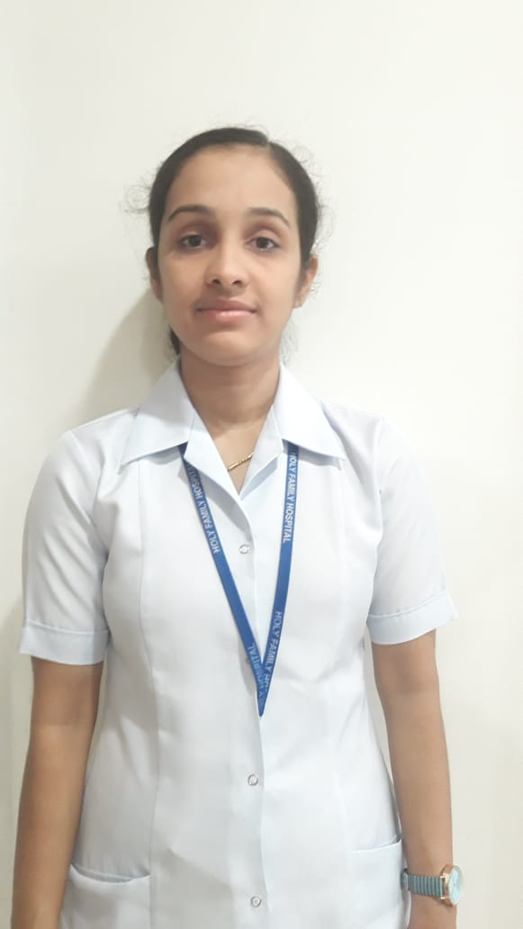

SAHAYA aUSTIN PUSHPA
  - FEMALE STAFF NURSE
REGISTERED staff nurse with 3 years and 6 months of experience IN nicu, picu AND PEDIATRIC ward.

Objective
Resourceful and extraverted staff nurse experienced in NICU, PICU and Pediatric ward, in pursuit of a job as a staff nurse in a reputed hopital where I can contribute to its growth with my equipped skills and dedication.
Skills & Abilities
- Multi Language Speaking (English, Hindi, Tamil, Malayalam)
- Punctuality, Dedication and commitment.

ADDRESS
Holy Family Hospital, Okhla Road, New Delhi, India-110025
 +91 9205315624
austinlopez182@gmail.com
 Austin Lopez

Post basic BSC NURSING

King george medical university
Lucknow, India. 2013-2015.
- GENERAL NURSING MIDWIFERY
NAZARETH SCHOOL OF NURSING
Allahabad, India. 2009-2013

- HIGHER SECONDARY
ST. MARY’S HIGHER SECONDARY SCHOOL
Colachel, Tamil Nadu, India. 2007

SPECIAL TRAINING PURSUED
- Recent Trends in Nursing
- Certificate of Organizing Workshop
- Participated as a delegate in INDO-US Emergency Medicine

Experience

HOLY FAMILY HOSPITAL, NEW DELHI, INDIA.

Septemper 2015 to APRIL 2019
- Performing basic nursing procedures such vital signs taking, monitoring, cardio pulmonary resuscitation (CPR).
- Ability to start, terminate an intravenous line and caring naso-gastric tubes, OG tubes on very tiny infants and children.
- Keep parents and families updated on their loved ones.
- Know how to perform accurate drug dose calculations according to the age of infants and children.
- Know how to use and adjust complex and specialized equipment like ventilators, incubators, C-PAP, HFNC.
- Infant is very different from adults. Infants cannot communicate verbally when in pain, their bodies respond differently to medications and treatment and they must be protected from potential dangers.
- Must also understand and be vigilant to prevent harm from risks that specifically effect newborns such as temperature changes or excess oxygen.
- Give children medication in the form of injections pills and liquids based on their medical needs.

PERSONAL PROFILE

Date of Birth: 05-02-1992
Gender: Female
Marital Status: Unmarried
Nationality: Indian
Passport No: N5113670
Validity: 21-12-2025

Refereces

Mrs. filomina J. thomas (Nursing Superintendent)

holy family hospital

Okhla road, NEW DELHI-110025
administration@holyfamilyhospitaldelhi.org Contact No: +909-26845900
- SR. LINET (PRINCIPAL)
B.C.M COLLEGE OF NURSING
Contact No: +91 9005170620

- SR. PREMA (PRINCIPAL)
NAZARETH SCHOOL OF NURSING
Contact No: +0532-2400337

DECLARATION

I do hereby declare that the particulars of information and facts stated herein above are true, correct and complete to the best of my knowledge and belief.
SAHAYA AUSTIN PUSHPA

