CURRICULUM VITAE
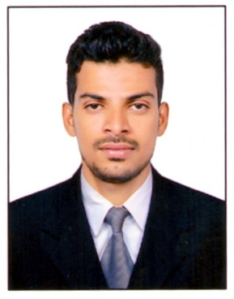

Mohammad Majeed Ahmed
Electrical Engineer
E-mail:majeedahmed.0505@gmail.com
Contact: +974 -66890174
Visa status: Engineer Visa (Transferable visa with NOC)

Career Objective:
To be involved with an organization that encourages me to participate effectively and Endeavour’s me to work as electrical engineer for satisfying organizations standards and objectives.

Educational Qualification:
B.Tech.in Electrical Engineering Jawaharlal Nehru Technological University-Hyderabad, India 2015.
Board of Intermediate Education A.P Hyderabad.
Vocational in Electrical wiring & servicing of Electrical appliances(EW&SEA)2011.

PROFESSIONAL EXPERIENCE: 5 YEARS
1) Worked in A.P. Electricals and Engineers pvt. Limited, (India)
Since OCT-2013 to OCT-2018 as an Electrical Engineer (Projects).

PROJECT SUMMARY
- Lanco Hills (Residential Luxury Villas)-India (oct2013 to may2015)
- Alembic Pharmaceuticals Ltd – India (june2015 to oct2017)
- Chemo Pharma Laboratories Ltd-India (nov2017to oct2018)

Job Responsibilities:

- Reporting to Construction Manager &amp; Project Manager about Site activities.
- Preparation and Implementation of Electrical Drawings.
- Executing the work on site as per Drawings with safety in a professional way
- Preparing daily report of work done and submitting to the project manager
- Handling the company Manpower and sub-contractors.
- Execution of Lighting, Power circuits, UPS circuits and Distribution boards (DB)
- Terminations in overall project as per the drawings.
- Preparation of load calculations and cable size calculations.
- Execution of cable tray laying, LT cable laying, and LT Panels terminations.
- Erection, Installation, and Termination of AC drives, VFD drives and UPS.
- Execution of ELV system works( fire alarm, PA system,)
- In-charge of all electrical execution of the project.
- Responsible for Erection, Installation, Commissioning, of HT/LT Panels (HT VCB
- Panel, PCC, MCC, APFC, MLDB, MPDB, HVAC, and AHU Control panels) and Utility
- Equipment’s (Chiller, Air Compressor, cooling towers) in the plant.
- Handling Earth grid and Transformers Neutral works.
- Erection and testing of Transformers.
- DG and Transformers Bus Duct Erection.
- Erection and testing of Transformers.
- Preparation and implementation of preventive maintenance schedule.
- To Keep Safety First. Live the Safety stand, adhere to the safety responsibilities.
- Accountable for planning, scheduling & monitoring the work progress of electrical systems as well as CCTV’s, access control systems and other ELV Systems.

KEY SKILLS AND ABILITIES:
- Basic Knowledge on AutoCAD.
- MS office
- Ability to work both strategically and hands-on.
- Excellent communication, managerial and interpersonal skills.
- Ability to work in a team environment and collaborate with cross-company departments.
- Ability to blend with any environment.

Personal Details:
Marital status : Married
Nationality : Indian
Present Location : Available in Qatar
Languages Known : English, Hindi and Telugu
Visa status : Engineer Visa (Transferable visa with NOC)

Declaration:

I hereby declare that all the Information provided by me in this Application is Factual and Correct
to the best of my Knowledge and belief. Relevant Documents will be submitted to support them when
needed.

MOHAMMAD MAJEED AHMED

