LIBU AUGUSTIN  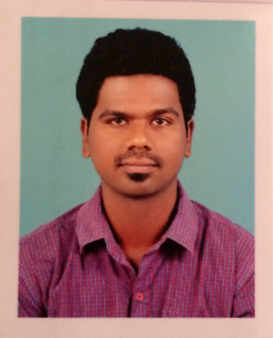  libuaugustine@gmail.com  mobile : 74793576  Permanent Address  SHINI NIVAS,VAYAL PURAYIDOM,VADDY  KOLLAM,KERALA  INDIA  691013.  Computer Skills  MS OFFICE  C LANGUAGE  COMPUTER HARWARE  COMPUTER NETWORKING  Reference  RAJEEV  SITE ENGINEER  VIOM NETWORKING  TRIVANDRUM  PH:+91 9037002056  Passport No: L 7938723  Personal Data  Date of Birth : 8 NOV 1987  Nationality : INDIAN  Marital Status: SINGLE  Languages Known  English  Hindi  Malayalam  Tamil | CURRICULUM VITAE  Objective  - Intend to build career with leading corporate of Hitech environment with committed and dedicated people, which will help me to explore myself fully and realize my potential and to contribute my education and skills in a position with a growing and dynamic firm.  Professional Profile  - Worked as a Project Engineer at VIOM NETWORK LIMITED  - From January 5th 2014 to October 2017  Personal Skills  Comprehensive problem solving abilities,  Verbal and written communication skills,  Ability to deal with people diplomatically,  Willingness to learn,  Team facilitator,  Strong Organization skills,  Engineering Industry Knowledge,  Time management skills,  Strong Command of Task delegation,  Understanding of Construction process  Education  ADVANCE DIPLOMA IN PROCESS CONTROL  INSTRUMENTATION  (2016)  SIIT,ITI  GOVERNMENT OF INDIA .NCVT  DIPLOMA IN ELECTRICAL AND ELECTRONIC  ENGINEERING  (2010-2013).  St JOSEPH POLYTECHNIC COLLEGE,  ANNA UNIVERSITY CHENNAI.  COMPUTER HARDWARE&NETWORKING  (2008)  JAN SHIKSHAN SANSTHAN  GOVERNMENT OF INDIA  HIGHER SECONDARY  (2007)  C0-Operative college  Affliated to Secondary School Leaving Certificate Exam(Kerala  Secondary Education (Xth Standard )  (2005)  St Aloysius Boys High School  Affliated to Secondary School Leaving Certificate Exam(Kerala)  Assets  - Effective Communication skills and leadership qualities.  - Highly initiative and carrier minded .  - Very creative and adaptable.

Technical QualificAtion:
Obtained Post Graduate Diploma in Industrial Automation (PGDIA) from Technocrat Automation Pvt Limited (IAO Accredited) Chennai, with 6 months hands on practical experience in Industrial Automation Tools specializing in PLC, DCS, SCADA and VFD.

COMPUTER/ Technical Skills:
- Experienced in handling computer hardware and have been into sales and service of computers.
ACADEMIC Project:
Main Project:
Project Title: Mobile Base Home Appliance Controller
This project was done on a frequency based program. There will be 2 frequencies for a single number low and high respectively. Each number has its own controlling option. Consider that 1 is the option for light, when we make a call with that number it gets accepted and simultaneously we have two keys one to switch on and other to switch off the light.

EXTRA CURRICULAR ACTIVITIES:
Plays football, cricket, and believe I am well versed in both.

industrial visit:

Visited Indian Railways, Madhukkara, studied the operations of the Indian Railways, track mechanisms signaling, etc.

Declaration

I hereby declare that all the details given above are true best of my knowledge.

---------------------------
LIBU AUGUSTIN

