CURRICULUM VITAE
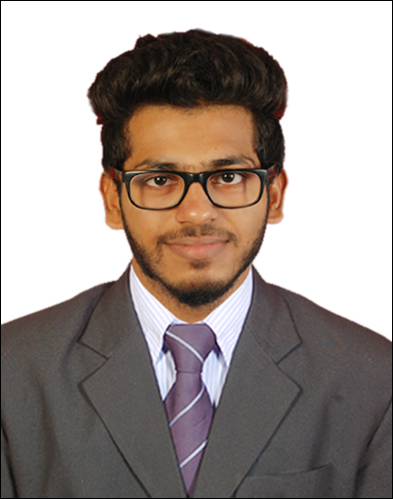
MOHAMMED IQUAN ABDUL

Contact: +91 9036428483 / +97470402128

Email: mohdiquan10@gmail.com

CAREER OBJECTIVE
To commit myself into a challenging position within an organization, that will allow me to grow professionally and optimize my knowledge and skills to eventually excel in my performance. To secure a position where my ability to communicate and liaise effectively with a diverse client group in a friendly and diplomatic manner can be put to good effort for the growth of the company.

PROFESSIONAL EXPERIENCE

Airtel, Mangalore, India (April 2015 – February 2018)

Relationship Executive – Indoor Sales

- Sales of postpaid and prepaid mobile and internet connections.
- Meet targets set on monthly basis.
- Handle walk-in customers and sell mobile phones and recharge cards.
- Set up Kiosks to promote the new launch products.
- Maintain day to day activities.
Cameez Clothing, Bangalore, India (July 2013 – March 2015)

Sales supervisor

- Making Quotations

- Supplying Quality Products to customers Satisfaction.

- Achieving sales Targets

- Making MIS Report

- Collection Of cash

- Follow-ups for Payment

- Marketing

EDUCATIONAL EXCELLENCY

- Advanced Diploma in HSE and FIRE SAFETY and EMERGENCY MANAGEMENT from Western Institute of Technology, Kadri, Mangalore, affiliated to Mangalore University (2013)
- P. U. C. (Commerce) passed from Rosario Composite PU College, Mangalore (2012)
- S. S. L. C. passed from Government Junior College for Women(Exam Center), Mangalore (2009)

COMPUTER PROFICIENCY

- Basics in computer application and internet properties.
- MS-Word, MS-PowerPoint.

PERSONAL SKILLS

- Ability to work independently or in a team environment
- Self-motivated in completing the given assignment within the scheduled time frame
- Good command in oral and written English.
- Can work with minimal supervision under pressure.
- Computer literate with knowledge of basic programs.
- Good decision making and time management skills

PERSONAL PARTICULAR

Gender : Male
Date of Birth : 12th March 1993
Marital Status : Single
Nationality : Indian
Passport Number : L2722103
Date of Issue : 07/06/2013
Date of Expiry : 06/06/2023
Language Know : English, Hindi, Malayalam, Kannada.

DECLARATION

I hereby declare that the above-mentioned details are true to the best of my knowledge and belief.

Place: Mangalore MOHAMMED IQUAN A

