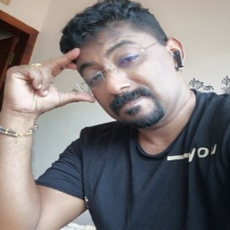

Targeting senior level-assignments in Talent Acquisition/ Employee Engagement/ Learning & Development with an organisation of high repute
.
urabh Gupta
Commercial Manager

PHOTO
VARGHESE CHERIAN
HR Generalist

bychrd@gmail.com, benhrd75@gmail.com 00974-66469127

Executive Profile  - A performance-driven professional offering over 22 years of rich experience in ensuring smooth running as well as enhancement of global centralized HR process operations along with introduction of right practices in alignment with business operations  - Expertise in manpower planning & integrated talent management, transformation and development with honed skills in sourcing the best talent from diverse sources (after identification of manpower requirements in consultation with heads of different functional & operational areas) along with other corporate HR related functions; viz. on-boarding, induction, onsite inclusivity, advancement planning, communication calendars, IR issues, so on  - Skilled in maintaining effective employee relations with staff across all hierarchical levels in the organization on day-to-day matters through role enrichments, feedback sessions & disciplinary proceedings, thereby establishing a collaborative culture through continuous engagements; effective in empowering employees to voice their opinions / grievances on a common platform  - Expertise in Setting up of the following Processes like Onboarding, Induction and Orientation, Timesheet, Work Contracts, Grievance Management and Exit Process  - Skilled in formulating the documents related to the hired employees including Project Invoices and Supplier’s Invoices including other documents  - Keen communicator with a love for people and an excellent ability to relate to stakeholders communication in a cross-cultural set-up  - Successful in managing end-to-end HR processes at different levels in a matrix structure and ensuring risk & compliance for the business  Education & Credentials  - Bachelor of Arts (BA) from University of Kerala – Year 1994 to 1996, Trivandrum  - Diploma in Computer Application (DCA) - Year 1994 (July), Trivandrum  Trainings Attended  - Travel and Tourism, Training and Practice with UNTA, Umm Al Quwain in 1996  - Training course of Microsoft Office, Pearl Computers, Umm Al Quwain in 1996  - Online Course on Psychiatry Management from Royal Institution, Cochin in 1998 | Key Impact Areas    On-boarding & Induction  Employee Engagement  Organizational Development  Competency Development  Stakeholder Management  Talent Acquisition & Management  Learning & Development  Performance Management  Policy & Documentation  Compensation & Reward Management  Soft Skills    Innovator  Motivator  Key Skills  Analytical  Communicator  
Career Timeline
Bhatia General Contg. & Power Machines, UAE
Hitachi Zosen Corporation-Japan, UAE
ABV Rock Group Co. Ltd., KSA
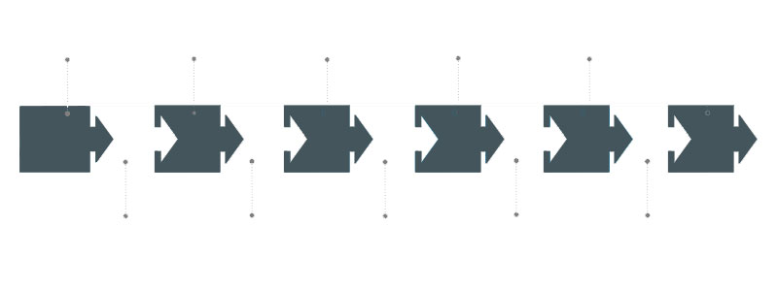
Umm Al Quwain National Travel Agency, UAE
Petron Emirates Contracting, UAE
Proline General Maintenance & Construction, UAE
1995-96
1996-97
1997-03
2003-07
2008-09
2010

Professional Experience
Since Mar’10 ABV Rock Group Co. Ltd., KSA as Senior Personnel Officer

Feb’08 – Mar’09 Proline General Maintenance & Construction, UAE as Asst. HR Manager

Feb’03 – Nov’07 Bhatia General Contg. & Power Machines, UAE as Asst. HR Manager
Key Result Areas:
- Delivering quality hiring by steering talent sourcing within allocated budgets / time frame including synchronizing with the consultant, shortlisting the candidates, scheduling interviews & participating in interviews
- Expert Planner & Implementer: building and deploying process improvement initiatives aiming at increasing the efficiency of the recruitment life cycle; resolving employee grievances and implementing disciplinary procedures
- Focusing on safeguarding that business units’ strategies are supported with HR programs and providing competitive advantage for the organization; guiding members of the organization regarding the implications of business decisions are understood and addressed
- Collaborating with executive leadership and trained team to develop and enhancing new hire on-boarding and training process resulting in improved new hire satisfaction and retention
- Recognizing opportunities for and carefully managing changes while providing extensive counsel, guidance, and influencing expertise
- Establishing new employee orientation, innovative online and offline programs for employees at all levels and new communication tools to improve morale and engagement
- Managing screening & short-listing of profiles as per requirement; negotiating on salaries & finalizing as per the offer; conduct exit interviews to identify reasons for employee termination
- Addressing disputes, complaints, grievances of all employees and resolve the issues in minimum time. To foster a conducive working environment through employee relations activities and communication
- Supervising the development of tools to assist employees in benefits selection through compensation decisions
- Designing benefits policies to ensure that programs are current, competitive & in compliance with legal requirements
- Front-leading the advancement of business unit workforce strategy, providing decision support
- Encouraging team work and focusing on team building by recognizing non- corrective behaviour, through personal interactions, training and workshops

Previous Experience
Mar’97 – Jan’03 Petron Emirates Contracting, UAE as HR Admin Officer

Mar’96 – Jan’97 Hitachi Zosen Corporation-Japan, UAE as Sr. Admin Officer

Sep’95 – Feb’96 Umm Al Quwain National Travel Agency, UAE as Ticketing Officer (Training)

Notable Accomplishment Across The Career
At ABV ROCK GROUP LTD., Saudi Arabia

- Performed difficult staffing duties, including dealing with understaffing, refereeing disputes, firing employees, and administering disciplinary procedures
- Successfully negotiated in bargaining agreements and help interpret labor contracts
- Supervised legislation, arbitration decisions, and collective bargaining contracts to assess industry trends
- Steered special projects in areas such as pay equity, savings bond programs, day-care, & employee awards

At Proline General Maintenance & Construction (LLC)
- Led various lectures in order to keep the employees aware about the growing competitions in the market and the need to be constantly upgrading the skills of the employees
- Focused on signing:
  - Leave applications all staff & workmen
  - Correspondence such as warning letters, circulars relating to HR
- Managed the reservations and arrangement of ticket of Directors and other employees in the company

At Petron Emirates Contg. & Mfg. Co. (LLC)
- Attended various Labour, Immigration, Visa Renewal & Stamping of all employees
- Engaged in the filling of Passport renewal applications of all employees prior to expiry of 2 months and submitting to consulates for renewal
- Administered various contract insurances such as EAR/TPL policies including Land & Transit Insurance. Apart from this Company Staff & Workmen policy, Motor insurance and Travel insurance of Directors
- Formulated medical insurance claim of employees to the insurance company
- Generated training reports of all staff for ISO audit purpose
- Published advertisement in newspapers such as staff, labour accommodations and manpower requirements
- Floated enquiries to various agencies regarding manpower requirements in category according to the requirements
- Gained knowledge on accounting package Tally 6.3


Personal Details

Date of Birth: 20th July 1975
Mailing Address: Al Hilal, Doha, Qatar
Languages Known: English, Hindi, Malayalam and Tamil
Passport No: L6657021
Driving Licence: Saudi/UAE/Indian Driving Licence

