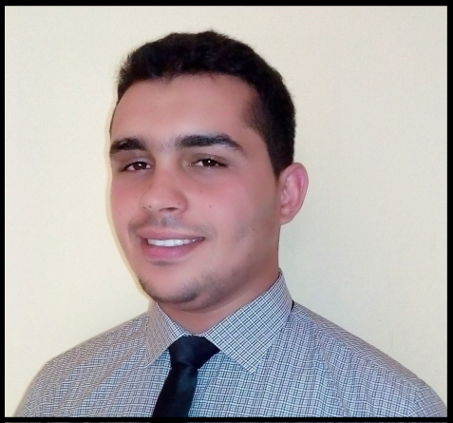
Personnel information:
Date and Place of Birth: 26 October 1992 SFAX-Tunisia
Marital Status: Single
Mobile No: (+974) 70202863
Email: faresbahri@hotmail.fr
Address: Doha, Qatar
Visa status: Work Visa
Objective:
To contribute to the success of an organization through my in-depth knowledge and skills related to the field of my experiences, and to gain knowledge and experience at the same time.
Post can be occupied:
- ELECTROMECHANICAL ENGINEER
- SUPERVISOR
- MECHANICAL ENGINEER
- ELECTRICAL ENGINEER
- AUTOMATION ENGINEER

Education History:

- 2014-2017 Master of Science in Engineering
Place: Polytechnic Institute of Advanced Sciences SFAX
Specialty: Electromechanical Engineering
- 2011-2014 Bachelor of Science in Electrical Engineering
Place: Higher Institute of Technological Studies (Sousse)
Specialty: Industrial automation and IT
- 2010-2011 mathematics baccalaureate
Place: Secondary High School AGAREB 2 SFAX
Grade: good
Internship
- February 2012 Worker internship
Place: LACROIX ELECTRONICS HAMEM-ZRIBA, ZAGHWEN, Tunis
About: viewing the installation cycle of electronic cards and observing the troubleshooting task at the end of cycle.
- February 2013 internship technician
Place: Carthago Ceramic Poulina, SFAX, AGAREB, Tunis
About: maintenance and installation of the ROTOCOLORE machine
- February to June 2014 : Final-year internship
Place: ISET SOUSSE, Tunis
About: Study, design and realization of electronic cards communicated based on microcontrollers and CAN bus.
- July 2015 : Worker internship
Place: Metal construction service HOUDA, SFAX, TUNIS
About: design of a car creek (CAD Solidworks)
- July 2016 : Engineer internship
Place: domestic Security Solutions, SFAX, TUNIS
About: mobile support design of a surveillance camera based on Solidworks
- February to June 2017: Final-year internship
Place: Industrial wiring company SIG 2, SFAX, TUNIS
About: Study, design and realization of a hydraulic wire reel
Work History:
January 2018 - UNTIL NOW ECE AlSARH Holding Group QATAR

Electromechanical Engineer: Manager Sub-Base Mixing Plant (CBM Mixer)
- Supervisor CBM production
- Evaluating Information to Determine Compliance with Standards
- Controlling Machines and Processes
- Request for basic materials and control packing and load machines
- Delivery of production, works and maintenance reports
- Inspecting Equipment, Structures, or Material
- Schneider automation control
- Supervision automate program
- troubleshooting and problem solving
- Monitor Processes, Materials, or Surroundings
- quality control
- team building
- Control Precision
- mechanical, hydraulic, electrical proficiency (Mixer and other machines)
January 2016 – October 2017 TEJRA Company (CLIEA) - SFAX, TUNISIA


SUPERVISOR
- Works with CLIEA automatic Society on site
- control machines with PLC software
- Fanuc Robot Accuracy Testing
- Take responsibilities for electrical substation construction procedure.
- Manage electrical assembly CABINETS
- Manage electrical assembly of machines
- Participation in the installation of a gas generator
- Synchronized field activities.
- Supervised a team work on site
- Prepared cost breakouts and budget reports for approval process.
- Gathering the necessary tools and mounting the jobs on to the automated machines.
- maintenance of the brick strapping machine
- mechanical maintenance for FANUC Robot
- hydraulic maintenance (hydraulic push tractor , hydraulic cylinder)
September 2014 – December 2015 ELECTROPUMP SEFI hydraulic – (SFAX) TUNIS

ELECTROMECHANICAL ENGINEER
- Negotiating and closing sales by agreeing terms and conditions.
- Offering after-sales support services.
- maintenance pumps
- Searching for new clients who could benefit from your products.
- Travelling to visit potential clients.
- Providing pre-sales technical assistance and product education.
- Solving client problems.
Skills:
Conception :
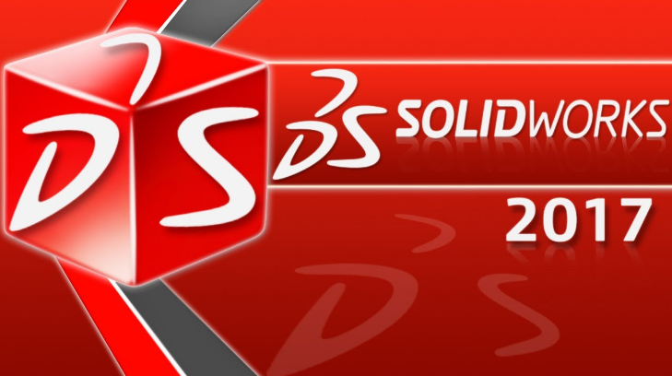
SOLIDWORKS
- Part/Assembly Design
- Sheet metal design
- Drafting

CATIA
TEKLA
ROBOT Structural Analysis
Programming:
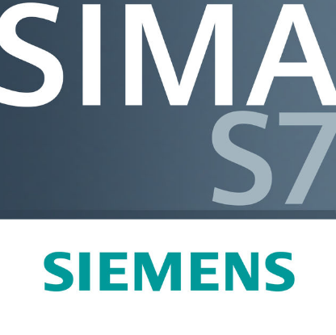
SIMATIC STEP 7 Professional
PIC C
Method, CNC machining
Mastercam

Calculation
Matlab
Languages: C++
SGBD : MICROSOFT ACCESS
Project management: Ms Projet

Highly Computer

- Windows 98,2000, 7, 8,10, NT, XP, Professional, and Vista
- Microsoft Excel
- Microsoft Word
- Power Point
Language Skills

- Arabic: mother tongue.
- English: Fluent (written and spoken).
- French: Fluent (written and spoken).

