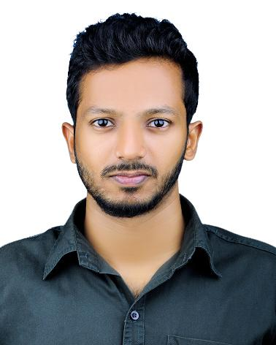
Ashif Vattamparambil
P O Box- 24271, Doha, Qatar
Mob: +91-9746934451
Home: +974-70305062
ashipva1@gmail.com

Professional Summary
Versatile HR Administrator who applies exceptional organizational skills with 2+ years of experience. Adept at administration, business development and payroll. Focused on ensuring efficient office operations through effective management methods. Currently looking to continue what has been a remarkably successful career by working for an ambitious company that wants to recruit talented individuals.

Core Qualifications
- 2+ years of professional experience in administration and business development.
- Capable of managing multiple tasks with an emphasis or retaining quality standards.
- Time Management and Prioritization.
- Adapts to change, work independently and exceed expectations.
- Ability to quickly assess and prioritize project requirements and office tasks.
- Familiar with all MS Office applications.
- Ability to meet tight deadlines.
- Good team player and motivator.
- Solid communication skills.

Work Experience
- Worked with Tectum Builders and Developers, India from October 2015 to September 2017 as HR Assistant.
- Worked with Rapposol Ventures Private Limited from June 2015 to September 2015 as Business Development Executive.

Work History
HR Assistant October 2015 to September 2017
Tectum Builders and Developers Thrissur, India

Supported the HR and Project Manager ensuring proper submission of proposals, purchase order, review, approval of vendor invoices and payroll. Provided timely schedule of ongoing projects to the senior management.

Job Description-

- Assisted the Project Managers in the day to day duties of Project’s administration.
- Prepared expense reports and corporate presentations. Organized office operations and procedures.
- Maintained accurate and up to date logs, track responses.
- Prepared time sheets of the employees to prepare the wages.
- Organized management and staff calendars and provided appointment reminders.
- Handled cash receipts and tracked cash withdrawals.
- Prepared quotations, prequalification documents and PowerPoint presentations.
- Prepared estimation sheets, studied the requirements and coordinated with the clients in case of any missing information/ or further information required.
- Generated confidentiality agreements and consulting agreements to support project teams.
- Ensured filing systems are maintained and up to date.
- Assisted with the tender administration and ensured the brochures, documents and contents are up to date.

Business Development Executive June 2015 to September 2015
Rapposol Ventures Private Limited Calicut, India

Responsible for all the marketing processes within the office, as well as providing general secretarial support to enable the smooth and effective running of the office.

Job Description-

- Arranged meeting with clients and carrying out product demonstrations.
- Generated business leads and followed up on sales opportunities.
- Dealt with incoming enquiries effectively and provided responses.
- Prepared quotes and proposals and when required assisted with direct marketing to existing and prospective clients.

Academic Credentials
Bachelor of Technology (B.TECH) 2011 - 2015
University of Calicut

Bachelor of Commerce (B.COM) 2013 - 2016
Madurai Kamaraj University (Distant)

Higher Secondary School Certification 2009 - 2011
SSMVHSS School, Edakkazhiyur - India

High School Examination (CBSE) 2008 - 2009
MIC English School, Akalad - India

Additional Credentials
CDC - PANAMA CDC
STCW - Fire Prevention and Fire Fighting
- Personal Safety and Social Responsibilities
- Personal Survival Technique
- Elementary First Aid
- Security Training for Seafarers with Designated Security Duties

Personal Details
- Date of Birth : 04th January 1993
- Sex : Male
- Age : 24 years
- Marital Status : Single
- Religion : Islam
- Nationality : Indian
- Country of Residence : Qatar
- Passport No : N6159965
- Visa : Visiting
- Linguistic Abilities : English, Hindi, Malayalam, Tamil

References
References will be available upon request.

