CURRICULAM VITAE

Name: Hashim Kebeer
ELECTRICAL DRAUGHTSMAN (CAD OPERATOR)
Visa Type: Residence visa With NOC
Total year of Experience: 7+ Years (Qatar & UAE)
Current Location: Doha, Qatar
Contact Mobile: +974 31471533 Email: hashvkr@gmail.com
Nationality: Indian

Application for the Post of ELV & Electrical Draughtsman (Cad Operator)

Intro Zone:

A responsible and challenging position with 7+years’ experience. Responsible for preparing all the necessary Electrical layouts, designing the drawings for various projects.

Profile:

3 Year Diploma in Electrical Engineering, self-motivated and hard-working individual, expert in handling electrical drafting jobs and design. Completed courses in AUTOCAD and also very good knowledge of latest version & other automation packages, which encompasses solid skill in operating computer and Basic knowledge of Revit and Navis.

Scope of work:

- Prepare model for all Electrical layout.
- Prepare & Design lighting layout.
- Prepare & Design small power layout.
- Prepare Earthing& Lightning protection layout.
- Prepare the cable tray layout.
- Prepare & Design Fire alarm layout.
- Prepare Data and Telephone layout.
- Prepare CCTV layout.
- Prepare Substation & Electrical room Details.
- BOQ of all kinds of Electrical works.
- Prepare DB load Schedule, Schematic & single line diagram
As per the concerned authority rules and regulations.
- Prepare shop drawings for all electrical layouts.
- Prepare As built drawings.
- Coordinating with other MEP services

Academic Qualifications and Certifications:

- Diploma in ELECTRICAL
- Higher Secondary Education Certificate (Higher Secondary board of Kerala)
- Secondary School Living Certificate (Board of Public Examination Kerala)
- AutoCAD Electrical 2010 Version (Autodesk Certificate Authorized Training Center Kerala)
- AutoCAD 2009 Version. Level (1) P.D.M (Autodesk Certificate Authorized Training
Center Kerala)
- AutoCAD 2009 Version. Level (2) 2D Drafting and Plotting (Autodesk Certificate
Authorized Training Center Kerala)
- AutoCAD 2009 Version. Level (3) 3d Modeling and Rendering-External Reference
(XREF) (Autodesk Certificate Authorized Training Center Kerala)
- AutoCAD 2008 Version.(American University Authorized Training Center Kerala)
- MS Office 2008 in G-Tech computer center Kerala

Professional Experience:

1. | From Oct-2016 to present ALYSJ Joint Venture (ALYSJ) For Qatar Integrated Metro project (Gold Line.). As ELV & Electrical Draughtsman | 
2. | 2 Year of Post Qualification Experience in Electrical Draughtsman, Consolidated contractors company (CCC) Abu Dhabi, UAE. | 
3. | 1 Year of Post Qualification Experience in Electrical Draughtsman, P&T Architects & Engineers Deployed by Omnix International Dubai, UAE. | 
4. | 2 Years of Post Qualification Experience in Electrical Draughtsman, Reliance contracting co. UAE. | 

Projects :( Major projects only)


- Company
ALYSJ Joint Venture Qatar

Project
Qatar Integrated Railway Project
Doha Metro: Gold Line Underground M006
For Qatar Railway Company

Project Description
Qatar Rail – Doha Gold Line Metro Project, Qatar.
Design and built Package of Green line Underground
Tunnel and Major 10 Stations.

Project Department
Construction

Position
Electrical & ELV Draftsman

Job role
Preparing of Fire alarm, Bacs, Low Voltage Power Supply, Lighting, Single line Diagram,
DB Schedule, Earthing, Lightning Protection System, Quantity Take Off.

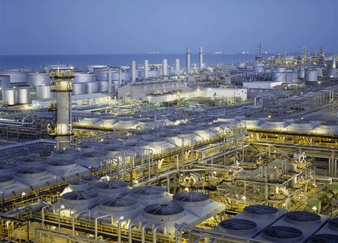
- Company
Consolidated contractors company (CCC) Abu Dhabi

Project
Lower Fares Heavy Oil Development Phase 1, Kuwait
For Kuwait National Petroleum Company

Project Description
Lower Fares Heavy Oil Development Phase 1, Kuwait
Engineering & Construction of the Production Support Complex.

Project Department
Engineering & Construction

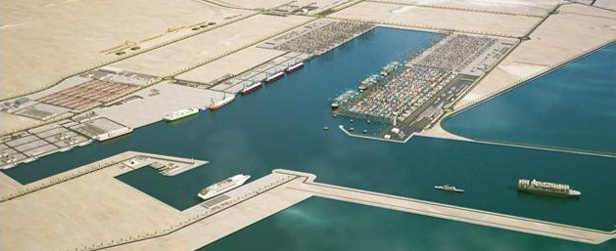
Project
New Port Project Container Terminal Infrastructure &
Utility Buildings, Qatar

Project Description
Engineering & Construction

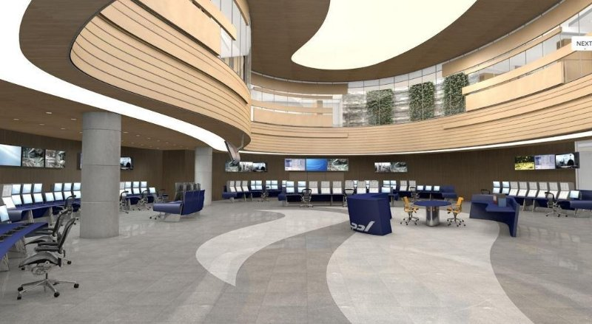
Project

ADGAS Main Control Building Upgrade Project,
Abu Dhabi

Project Description
Engineering & Construction of the New MCB and Existing CCB.

Position
Electrical Design Draughtsman

Job role:
Prepare model for all Electrical layout
Prepare & Design lighting layout
Prepare & Design small power layout.
Prepare Earthing& Lightning protection layout
Prepare the cable tray layout
Prepare & Design Fire alarm layout
Prepare Electrical room Details
Prepare shop drawings as per IFC
Prepare DB load Schedule, Schematic & single line diagram as per
The concerned authority rules and regulations.
Coordinating with other services

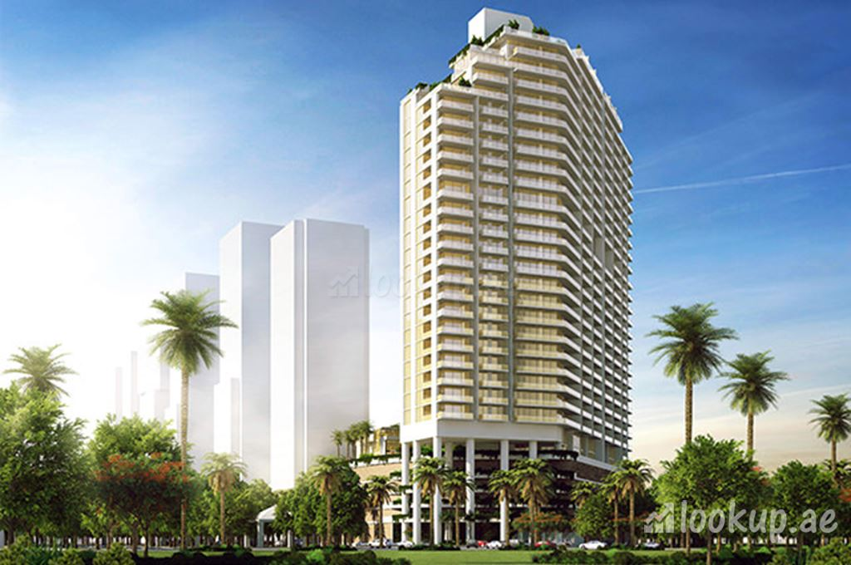
- Company
P&T Architects & Engineers

Project
Hameni Tower G+4P+27,
Residential Building Jumeirah Village Circle, Dubai
For Nazrod Limited, Dubai.

Project Description
Engineering Design & Construction

Project
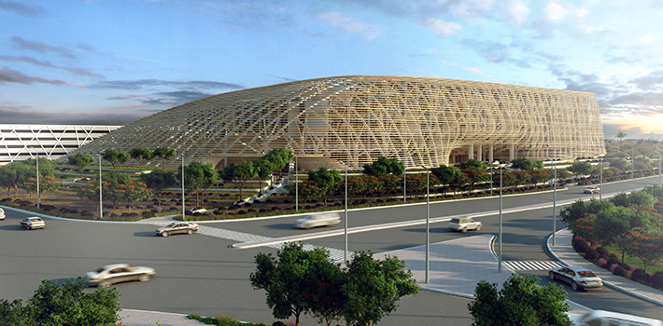
Solis Hotel and Educational City, Qatar
For Astad Project Management.

Project Description
Engineering & Construction

Job role
Prepare model for all Electrical layout
Prepare & Design lighting layout.
Prepare & Design small power layout
Prepare Earthing& Lightning protection layout
Prepare the cable tray layout
Prepare & Design Fire alarm layout
Prepare Electrical room Details
Prepare DB load Schedule, Schematic & single line diagram
as per the concerned authority rules and regulations
Coordinating with other services
Prepare Data and Telephone layout
Prepare CCTV and Access Control System layout.

Expertise Zone:

- Quick to study & implement.
- Adaptability capable of adapting to new environment and grasp work quickly.
- A proactive worker capable of working on own initiative and meet strict deadlines.
- Capable of working under pressure situation.
- Extensive experience in following fields:
- Familiar with Ms Office & computer application.
- Basic knowledge of Revit and Navis.

Other details:

- Good presentable personality and communication skills.
- Energetic enough to travel.
- Willingness to learn new emerging technologies.
- Disciplined and managed in the professional work culture.
- Ready to take up responsibilities and execute it successfully to full satisfaction of the client and the company.

Personal information:

Date of Birth & Age | 16th March 1988 & 30
Gender | Male.
Nationality | Indian.
Languages known | English, Hindi, Tamil & Malayalam
Passport No: | P3402031

Reference:

Abdul Vahid  Sr. Special System Engineer  ALYSJ  Gold line metro  akuzhiyil@goldlinemetro.qa | Ahmed Mosad  Sr. Electrical Coordinator  CCC  Abu Dhabi, UAE  AMosaad@ccc.ae

Conclusion:

I hereby declare that the, above- furnished details are true to my knowledge.

Sincerely,
Hashim Kebeer
Doha, Qatar

